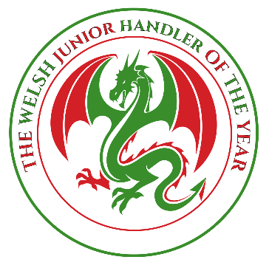
Please return your completed form with payment to:
Carly Mills-Jones
Llwyn
New Park Road
Holyhead, Anglesey
North Wales
LL65 1PH
01407 459062/07525 812885
mailto:Carlyjonescarlita@icloud.com

WELSH JUNIOR HANDLER OF THE YEAR COMMENTATOR NOTES
Held under the Auspices of Cardiff Canine Society

Competition to be held on: Saturday Feb 29th 2020 at:
*Clwyd Morgannwg Hall, Drover’s Court, Royal Welsh Showground, Builth Wells LD2 3SY
(Otherwise known as the Old Food Hall)

ENTRIES CLOSE: FEBRUARY 3RD 2020

BLOCK CAPITALS PLEASE
HANDLERS NAME………………………………………………………………………………………………………………………………

HANDLERS AGE…………………………………………………………………………………………………

HOW LONG YOU HAVE BEEN HANDLING………………………………………………………………..….

BREEDS HANDLED………………………………………………………………………………………….......

………………………………………………………………………………………………………………………

PROUDEST HANDLING MOMENT…………………………………………………………………………….

……………………………………………………………………………………………………………………..

