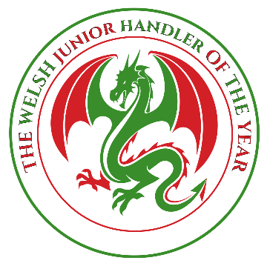
Please return your completed form with payment to:
Carly Mills-Jones
Llwyn
New Park Road
Holyhead, Anglesey
North Wales
LL65 1PH
01407 459062/07525 812885
Carlyjonescarlita@icloud.com

WELSH JUNIOR HANDLER OF THE YEAR COMPETITION
Held under the Auspices of Cardiff Canine Society

Competition to be held on: Saturday February 29th 2020 at:
*Clwyd Morgannwg Hall, Drover’s Court, Royal Welsh Showground, Builth Wells LD2 3SY
(Otherwise known as the Old Food Hall)

ENTRIES CLOSE: February 3rd 2020

CHECKLIST

○  YOUR CHEQUE
(Non-Refundable) Payable to ‘The Welsh Junior of the Year’
○  YOUR ENTRY DETAILS
○  YOUR PHOTOGRAPH
(Electronic Copy - 300 DPI - Copyright Released)
○  COMMENTATOR NOTES
○  NUMBER OF TICKETS REQUIRED…………………….

PLEASE RETURN THIS SHEET WITH ALL THE RELEVANT PAPERWORK
THANK YOU

